Steps to Create EC2 Instance in AWS (Amazon)
Follow the below steps to create an EC2 instance in AWS (Amazon):
Step 1: Login and Navigate to EC2 Dashboard
- Log in to your AWS Management Console.
- From the Services menu, choose EC2 under the Compute section.
- Under Resources, click Instances (Running) to view running instances (if any).
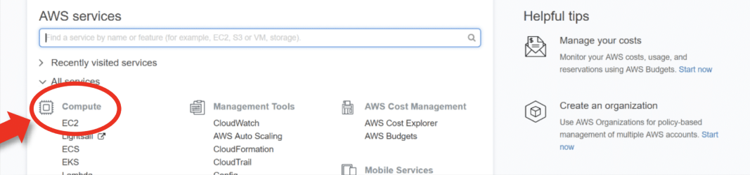
Under Resources >> Click on "Instances running" -- It will show if any EC2 instances are running or not.
Step 2: Launch a New Instance
- Click Launch Instance.
- On the "Launch an Instance" page, enter a name for your instance (e.g., my-first-ec2-server).
- You'll now configure your server settings.
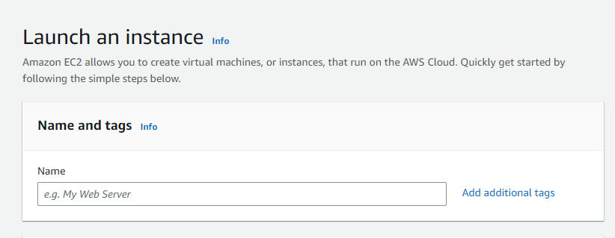Naming instance
Step 3: Choose Amazon Machine Image
- Select an Amazon Machine Image (AMI), which is the OS for your server.
- For beginners, choose Amazon Linux 2, Ubuntu, or Windows, depending on your needs.
- AMIs come preconfigured with OS and some software like templates.
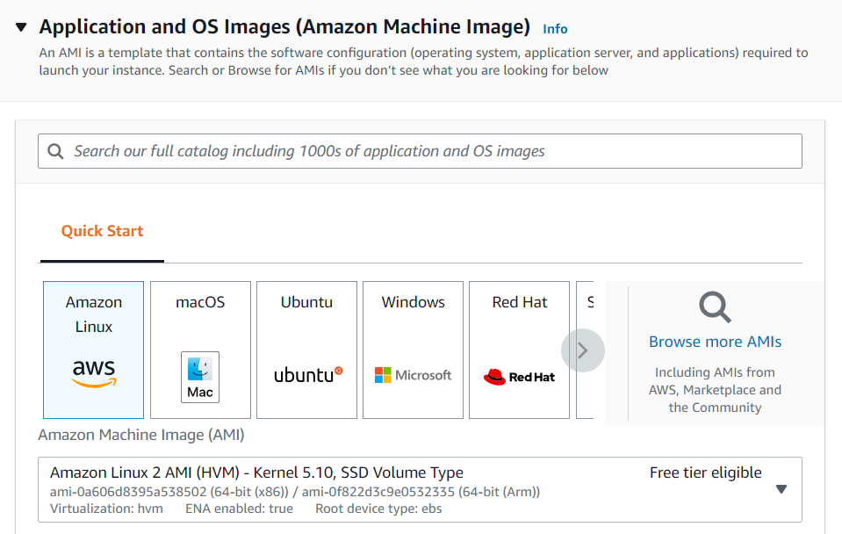Selecting AMI
Step 4: Select Instance Type
- Select the instance type (defines CPU and memory).
- For Free Tier, choose t2.micro — 1 vCPU and 1 GB RAM.
- Avoid selecting higher types like t2.small, t3.medium, etc., unless needed, as they may incur charges.
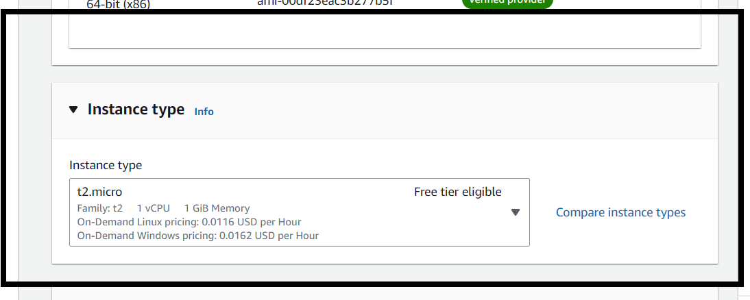Select instance type
Step 5: Configure Key Pair
1. EC2 instances use SSH key pairs for secure access.
2. Click Create new key pair:
- Enter a name.
- Choose file format: .pem for Linux/macOS or .ppk for Windows (for PuTTY).
- Download the key file and save it securely (you won’t be able to download it again).
3. Select the created key pair from the dropdown.
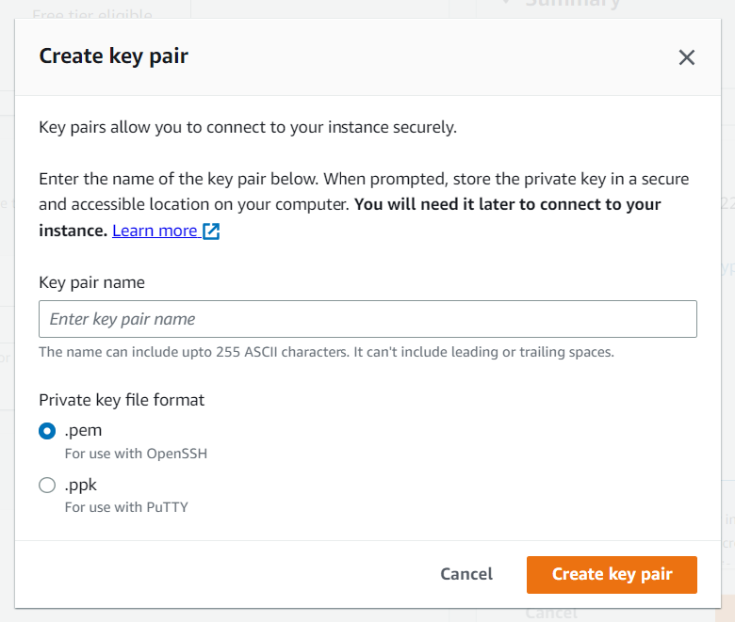Creating key pair
Step 6: Network and Storage Configuration
1. Network Settings: Use the default VPC and subnet unless you have specific networking needs.
2. Firewall (Security Group): Allow SSH (port 22) for Linux or RDP (port 3389) for Windows.
3. Storage Settings:
- Free Tier allows up to 30 GB of General Purpose SSD (gp2).
- Keep default (8 GB) or increase as needed.
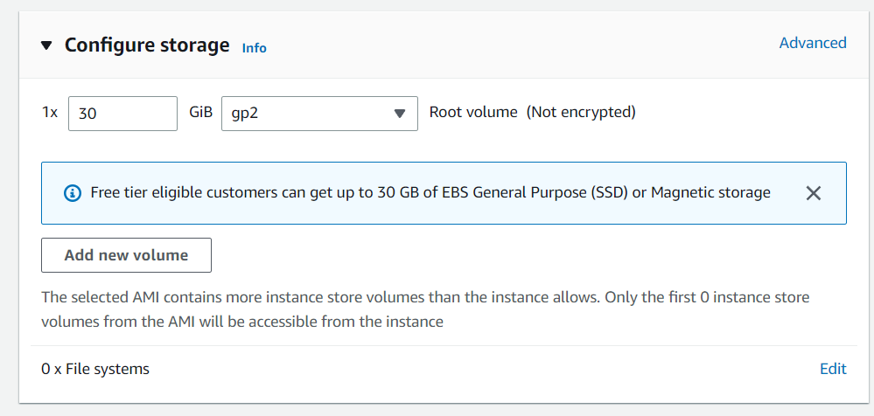
Step 7: Review and Launch
- Review all configurations to ensure they are Free Tier eligible.
- Click Launch Instance.
- You will see a confirmation page. Click View Instances to see your new server being initialized.
